Focus Group 3/6/2014

The following notes are from the feedback Carly and I (Phil London) received on March 6, 2014 regarding the Project STAY website prototype. Two people that use the site and one person that is not a regular user of the site were asked to contribute in the focus group.

Header/Navigation Bar

* We ultimately decided on changing the Header items to the following:
  + Home
  + Support
  + Contraception
  + STIs
  + About
* Each navigation bar item will have within it another navigation bar underneath that will let users look at the contents of that page before being sent to that page. For example, the “Support” page will have contents regarding Resources and an “Ask a Question Form”, these two items will be displayed when the user hovers over the “Support” nav-bar item.
* The focus group liked the color of the nav-bar, saying it was user friendly, however, additional logos are needed for the nav-bar items: Contraception and STIs and About (not sure what we decided on these, but Contraception is definitely up for debate in terms of its logo).

Logo

* Overall positive feedback for the logo. We could possibly add more to it. One person suggested connecting it to concepts like people, diversity, and urban communities. But mostly I think people appreciated its simplicity.

Two Sites or One?

* Something we had been struggling with was how to make the site appeal to users that are at high risk and users that are HIV positive. How would we get information to the users that are at high risk while still providing a supportive community to those that are HIV positive? We decided on one site for both. For those that are coming to STAY for the support, the newly added “Support” page will provide resources for support, videos of those that are HIV+ telling their stories for others to watch, additional resources and links to other sites, and an “Ask a Question Form” that the nurses or Dr. Cohall or others that are qualified can respond to. In terms of those that are at high risk, the Contraception and STIs tabs in the nav-bar will be targeted to them.
  + We also want to make it easy for those that are worried about the stigma of visiting a site such as this to quickly hide anything they are looking at. Therefore we decided on creating a template for the STI page, which will look like the following image.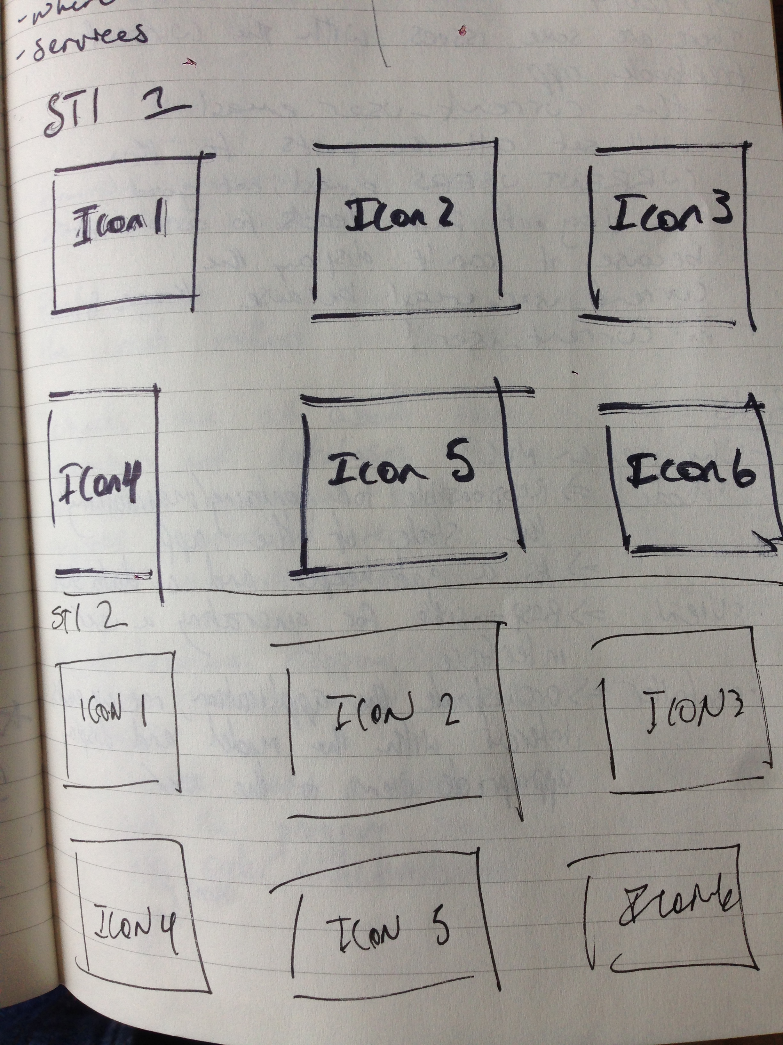
* With each icon being a descriptive icon of a topic/question for each STI, like “What kind of medicine do I need to be taking” as an image of a pill box. When each icon is hovered over it will flip and a description/answer to the question will be displayed. As soon as the user moves his/her mouse away the description will hide and the image will return.